**POWER SYSTEMS-II**

**UNIT-IV**

**Travelling Waves in power system**

**Definition:** Travelling wave is a temporary wave that creates a disturbance and moves along the transmission line at a constant speed. Such type of wave occurs for a short duration (for a few microseconds) but cause a much disturbance in the line. The transient wave is set up in the transmission line mainly due to switching, faults and lightning.

The travelling wave plays a major role in knowing the voltages and currents at all the points in the power system. These waves also help in designing the insulators, protective equipment, the insulation of the terminal equipment, and overall insulation coordination**.**

# Specifications of Travelling Wave:

The travelling wave can be represented mathematically in a number of ways. It is most commonly represents in the form of infinite rectangular or step wave. A travelling wave is characterised by four specifications as illustrated in the figure below.

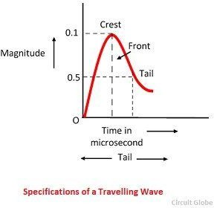

**Crest –** it is the maximum aptitude of the wave, and it is expressed in kV or kA

**Front –** It is the portion of the wave before the crest and is expressed in time from the beginning of the wave to the crest value in milliseconds or µs

**Tail –** The tail of the wave is the portion beyond the crest. It is expressed in time from the beginning of the wave to the point where the wave has reduced to 50% of its value at its crest.

**Polarity –** Polarity of the crest voltage and value. A positive wave of 500 kV crest 1 µs front and 25 µs tail will be presented as +500/1.0/25.0.

Surge is a type of travelling wave which is caused because of the movement of charges along the conductor. The surge generates because of a sudden vary steep rise in voltage (the steep front) followed by a gradual decay in voltage (the surge tail). These surges reach the terminal apparatus such as cable boxes, transformers or switchgear, and may damage them if they are not properly protected.

The transmission line is a distributed parameter circuit and its support the wave of voltage and current. A circuit with distributed parameter has a finite velocity of electromagnetic field propagation. The switching and lightning operations on such types of circuit do not occur simultaneously at all points of the circuit but spread out in the form of travelling waves and surges.

When a transmission line is suddenly connected to a voltage source by the closing of a switch the whole of the line in not energised at once, i.e., the voltage does not appear instantaneously at the other end. This is due to the presence of distributed constants (inductance and capacitance in a loss-free line).

Considered a long transmission line having a distributed parameter inductance (L) and capacitance (C). The long transmission line is divided into small section shown in the figure below. The S is the switch used for closing or opening the surges for switching operation. When the switch is closed the L1 inductance act as an open circuit and C1 act as a short circuit. At the same instant, the voltage at the next section cannot be charged because the voltage across the capacitor C1 is zero.

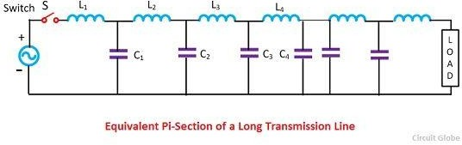

So unless the capacitor C1 is charged to some value the charging of the capacitor C2 through L2 is not possible which will obviously take some time. The same argument applies to the third section, fourth section, and so on. The voltage at the section builds up gradually. This gradual build up of voltage over the transmission conductor can be regarded as though a voltage wave is travelling from one end to the other end and the gradual charging of the voltage is due to associate current wave.

The current wave, which is accompanied by voltage wave steps up a magnetic field in the surrounding space. At junctions and terminations, these waves undergo reflection and refraction. The network has a large line and junction the number of travelling waves initiated by a single incident wave and will increase at a considerable rate as the wave split and multiple reflections occurs. The total energy of the resultant wave cannot exceed the energy of the incident wave.

Introduction Short circuit study is one of the basic power system analysis problems. It is also known as fault analysis. When a fault occurs in a power system, bus voltages reduces and large current flows in the lines. This may cause damage to the equipments. Hence faulty section should be isolated from the rest of the network immediately on the occurrence of a fault. This can be achieved by providing relays and circuit breakers.

The calculation of currents in network elements for different types of faults occurring at different locations is called SHORT CIRCUIT STUDY. The results obtained from the short circuit study are used to find the relay settings and the circuit breaker ratings which are essential for power system protection.

Symmetrical short circuit on Synchronous Machine The selection of a circuit breaker for a power system depends not only upon the current the breaker is to carry under normal operating conditions but also upon the maximum current it may have to carry momentarily

and the current it may have to interrupt at the voltage of the line in which it is placed. In order to approach the problem of calculating the initial current we need to study the behaviour of a synchronous generator when it is short circuited.

When an ac voltage is applied suddenly across a series R-L circuit, the current which flows has two components 1. a steady state sinusoid ally varying component of constant amplitude and 2. a non-periodic and exponentially decaying with a time constant of L/R. (which is also referred as the dc component current).

The initial value of the dc component of current depends on the magnitude of the ac voltage when the circuit is closed. A similar but more complex phenomenon occurs when a short circuit occurs suddenly across the terminals of a synchronous machine. A good way to analyze the effect of a three-phase short circuit at the terminals of a previously unloaded generator is to take an oscillogram of the current in one phase upon the occurrence of such fault.

Since the voltages generated in the phases of a three-phase machine are displaced 120 electrical degrees from each other, the short circuit occurs at different points on the voltage wave of each phase. For this reason the unidirectional or dc transient component of current is different in each phase. If the dc component of current is eliminated from the current of each phase, the short circuit current plotted versus time will be as shown in Fig. 3.1

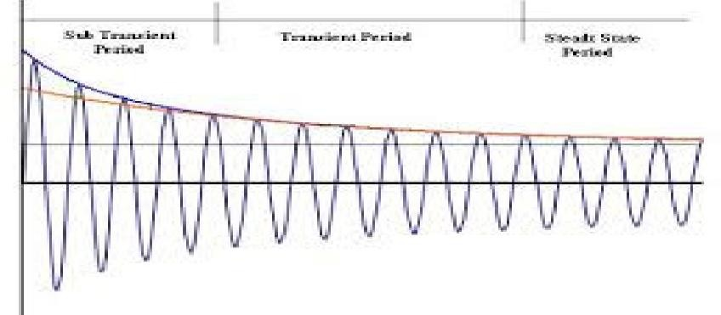



In the synchronous generator, generally the reduction of the air gap flux is caused by the mmf of the current in the armature which is known as the armature reaction effect. At the instant prior to short circuit, the no load armature current is very small resulting negligible armature reaction effect and maximum air gap flux.

When there is a sudden increase of stator current on short circuit, the air gap flux cannot change instantaneously due to eddy currents flowing in the rotor and damper circuits, which oppose this change. Since, the stator MMF is unable to establish any armature reaction, the reactance due to armature reaction is negligible and the initial reactance is very small and almost equal to armature leakage reactance alone.

This results in very large initial current as seen from Fig. 3.1. This period is referred as sub transient period. After a few cycles, the eddy current in the damper circuit and eventually in the field circuit decays to some extent and the air gap flux reduces due to partial armature reaction effect resulting in reduction in short circuit current as seen in Fig. 3.1

Now the machine said to function in the transient period. After another few cycles, the eddy current in the damper circuit fully decays allowing reduction in air gap flux due to armature reaction effect. Now the steady state condition is reached as seen from Fig. 3.1.

The RMS value of the current determined by the intercept of the current envelope with zero time is called the sub transient current |I ” |. Direct axis sub-transient reactance Xd ” is |Eg| / |I ” | where |Eg| is the RMS phase voltage at no load.

The RMS value of the current determined by the intercept of the current envelope leaving first few cycles with zero time is called the transient current |I ’ |. Direct axis transient reactance Xd ’ is |Eg| / |I ’ |.

The RMS value of the steady state short circuit current is |I|. Direct axis reactance Xd is |Eg| /

|I|.

The rms value of the steady state short circuit current is |I|. Direct axis reactance Xd is |Eg| / |I|.

The currents and reactances discussed above are defined by the following equations.

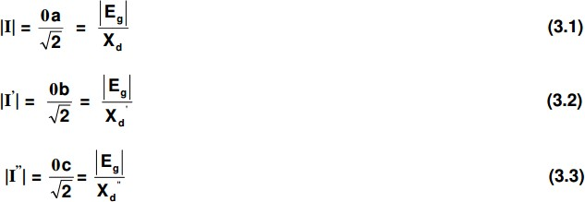

The sub-transient current |I”| is much larger than the steady state current |I| because the decrease in air gap flux caused by the armature current cannot take place immediately. So large voltage is induces in the armature winding just after the fault occurs than exists after steady state is reached.

However, we account for the difference in induced voltage by using different reactances in series with the no load voltage Eg to calculate currents for sub transient, transient, and steady state conditions.

Equations (3.1) to (3.3) indicate the method of determining fault current in a Equations (3.1) to (3.3) indicate the method of determining fault current in a generator when its reactances are known. If the generator is unloaded when the fault occurs, the machine is represented by Eg in series with the proper reactance.

The resistance is taken into account if greater accuracy is desired. If there is impedance external to the generator between its terminals and the short circuit, the external impedance must be included in the circuit.